How to get a LAPS password or BitLocker key

Open office 365 admin and click endpoint manager, if this is not here then they don’t use intune/LAPS
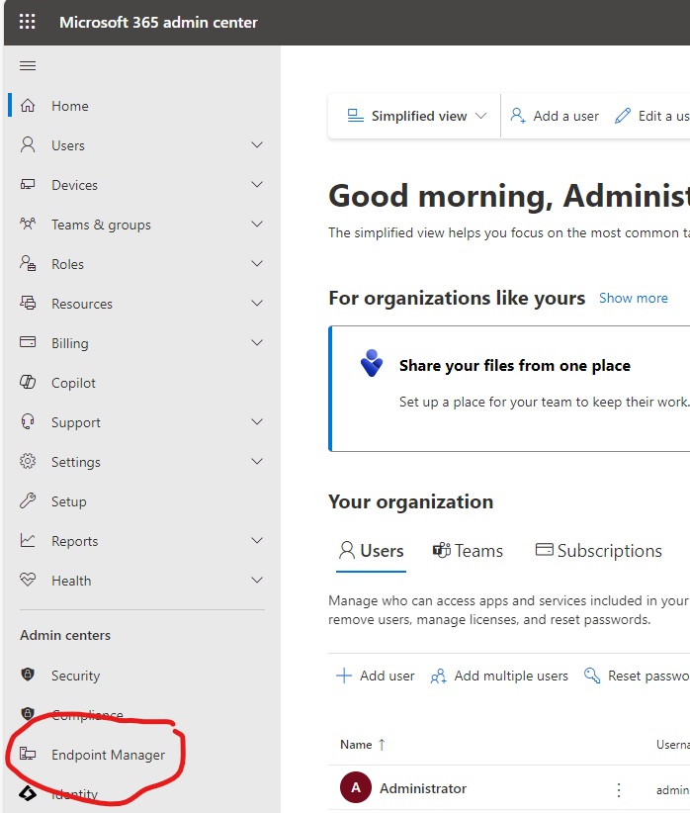
Once in endpoint manager select Devices – Windows – Search (optional) – Device of interest
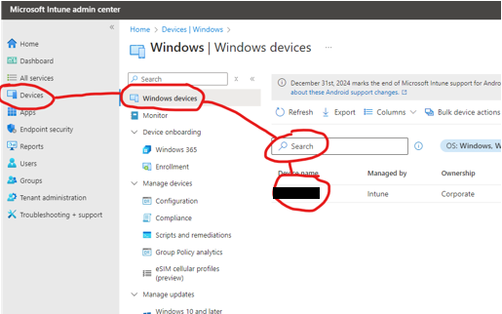
In the page for the device there is the Local Admin Password section
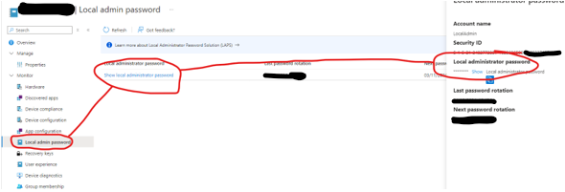
There is also the Recovery Key section for BitLocker
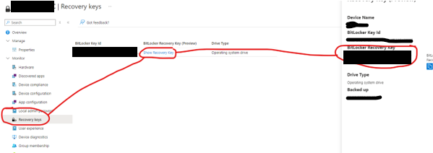
Finally, if you need to revoke the local admin password in the overview section for the computer click on the three dots and select to Rotate local admin password. You can also rotate BitLocker keys here
